**Russia-Ukraine War Tweets Sentiments Analysis and Topic Modeling**

**Yifei Song, Keying Gong, Zhirui Li, Hanjun Wei**

**Brown University, CS 2470**

# **Introduction:**

The current conflict between Russia and Ukraine has caused people and groups to suffer at different levels and aspects globally. To better understand Twitter users’ discourse and psychological reactions to this conflict, we use deep learning methods to analyze the tweets related to this conflict. We also want to track how the discussions and attitudes towards the conflict change over time. The result can have several practical usages, such as improving the donation campaigns and helping local communities to establish emotional support organizations. More generally speaking, we want to see how people outside of Russia and Ukraine are affected by the conflict. Through topic modeling, we can have a view of the most concerned subtopics related to the conflict, which would be a reflection on the effects on people’s daily life and mental states. The sentiment analysis part is a classification problem, we are trying to predict the posts’ sentiment into 11 different categories of sentiments. The topic modeling part is an unsupervised learning problem. We will train the model to cluster the posts into groups and then examine the features of each group.

# **Methodology:**

For sentiment analysis modeling, we will take a tweet as the input and return a list of probabilities with respect to 11 different sentiments (e.g. anger, love, disgust, etc). By doing so, we will be able to have a good sense of what sentiments are being included in this single tweet. After evaluating all tweets related to the Ukraine and Russian War, we will have a better sense of Twitter users (with English as the first language) overall opinion of this war from Feb. 02 till the present.

To accomplish this task, we will be using a Bidirectional Long Short-Term Memory (LSTM) and a sigmoid Dense layer. The reason we choose a BLSTM is that, unlike LSTM which only considers the sequential effect from the previous words, it allows us to capture the sequential relationship from both left and right. Thus, all words (except itself) in this tweet can be taken into consideration. Besides, because the length of every tweet in our dataset will stay unchanged, it will be reasonable for us to apply this method.

For model training, we input the labeled training dataset GloVe (Global Vectors for Word Representation) to an embedding matrix. Then, we created a bi-directional LSTM layer, each with 128 units. And we use a dense layer with a Sigmoid activation function to output the probabilities for each label (a total of 11 sentiment labels). Lastly, we tested our model on the test dataset with an F1 score of 0.66.

For topic modeling, we will implement an LDA model to capture latent topic clusters underlying all the Tweets from February 24, 2022 to May 1, 2022. LDA is an unsupervised learning method and the total number of clusters we try to find is 12 (this is a hyperparameter).

# **Results:**

Our sentiment prediction model can capture 11 sentiments. We discover that the top 3 sentiments over all periods (one period is defined as one week) are disgust, fear, and joy. Over 50% of the time the tweet will exhibit negative sentiments such as disgust and anger. Moreover, sentiments such as disgust and fear both experience a gradually decreasing trend. Positive sentiments such as joy experience a gradually increasing trend, which indicates that public opinion is slowly switching sides. People are focusing more on the positive part of this conflict.

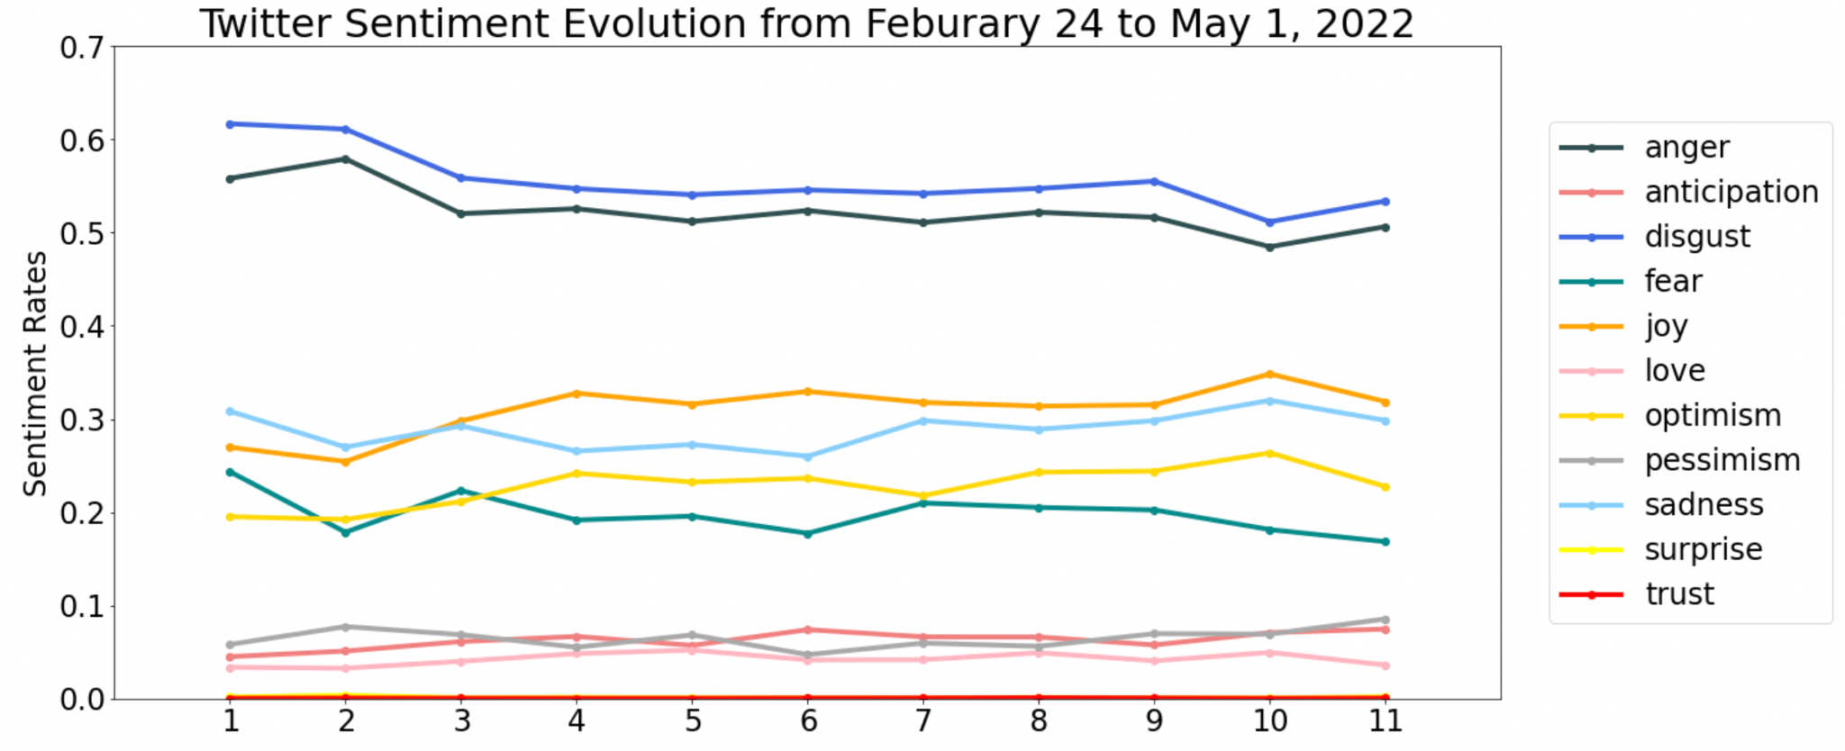

*Figure 1: Sentiments evolution for Tweets from February 24, 2022 to May 1, 2022. The x-axis represents each period (6 days). The y-axis represents the accumulated rate for each sentiment. Sentiments such as disgust and anger have a predominant percentage among all the sentiments. Sentiments such as trust have an occurrence rate nearly 0. Moreover, sentiments such as disgust and anger experience a gradually decreasing trend; sentiments such as joy experience a gradually increasing trend.*

After building the sentiment analysis model, we build a LDA (Latent Dirichlet allocation) model to gain a deeper understanding of the Ukraine Russia War twitter dataset. LDA allows us to detect latent topics that govern words in text corpora. In other words, by using LDA, we can find some natural groups of items (topics) even when we’re not sure what we’re looking for. Cluster 10 is one of the latent topics we learned from our dataset. We can see that terms such as life, good, protect, freedom, hope, stand, and love are classified together with Ukraine, which means that Ukraine is related mainly to positive terms.

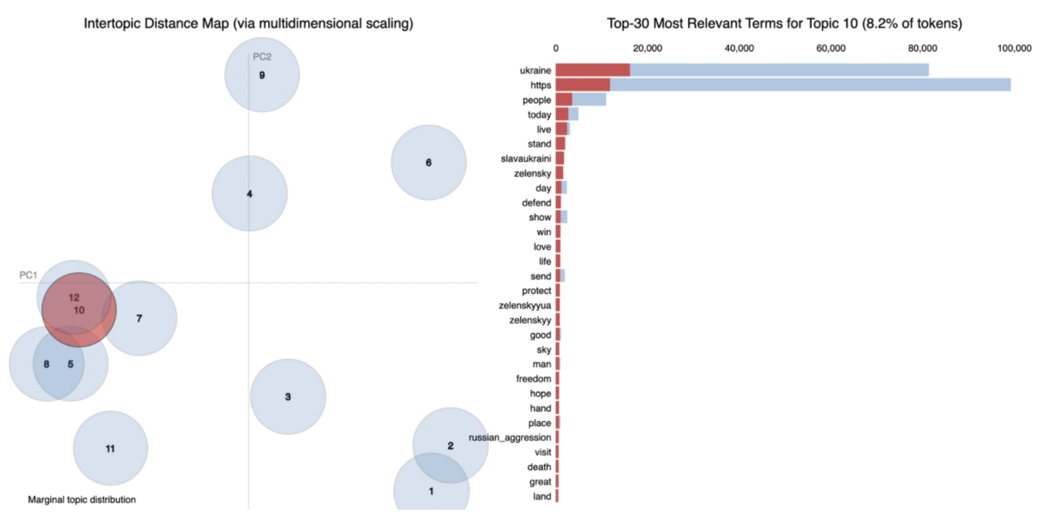

*Figure 2: The tenth topic cluster for our LDA model output. Although we don’t know the exact topic title for this cluster, we can check relevant words in this topic cluster.*

Whereas in cluster 6, war_crimes, genocide, stopwar are clustered together with Russia and Putin(president of Russia). This indicates that Russia is mainly related to negative terms.

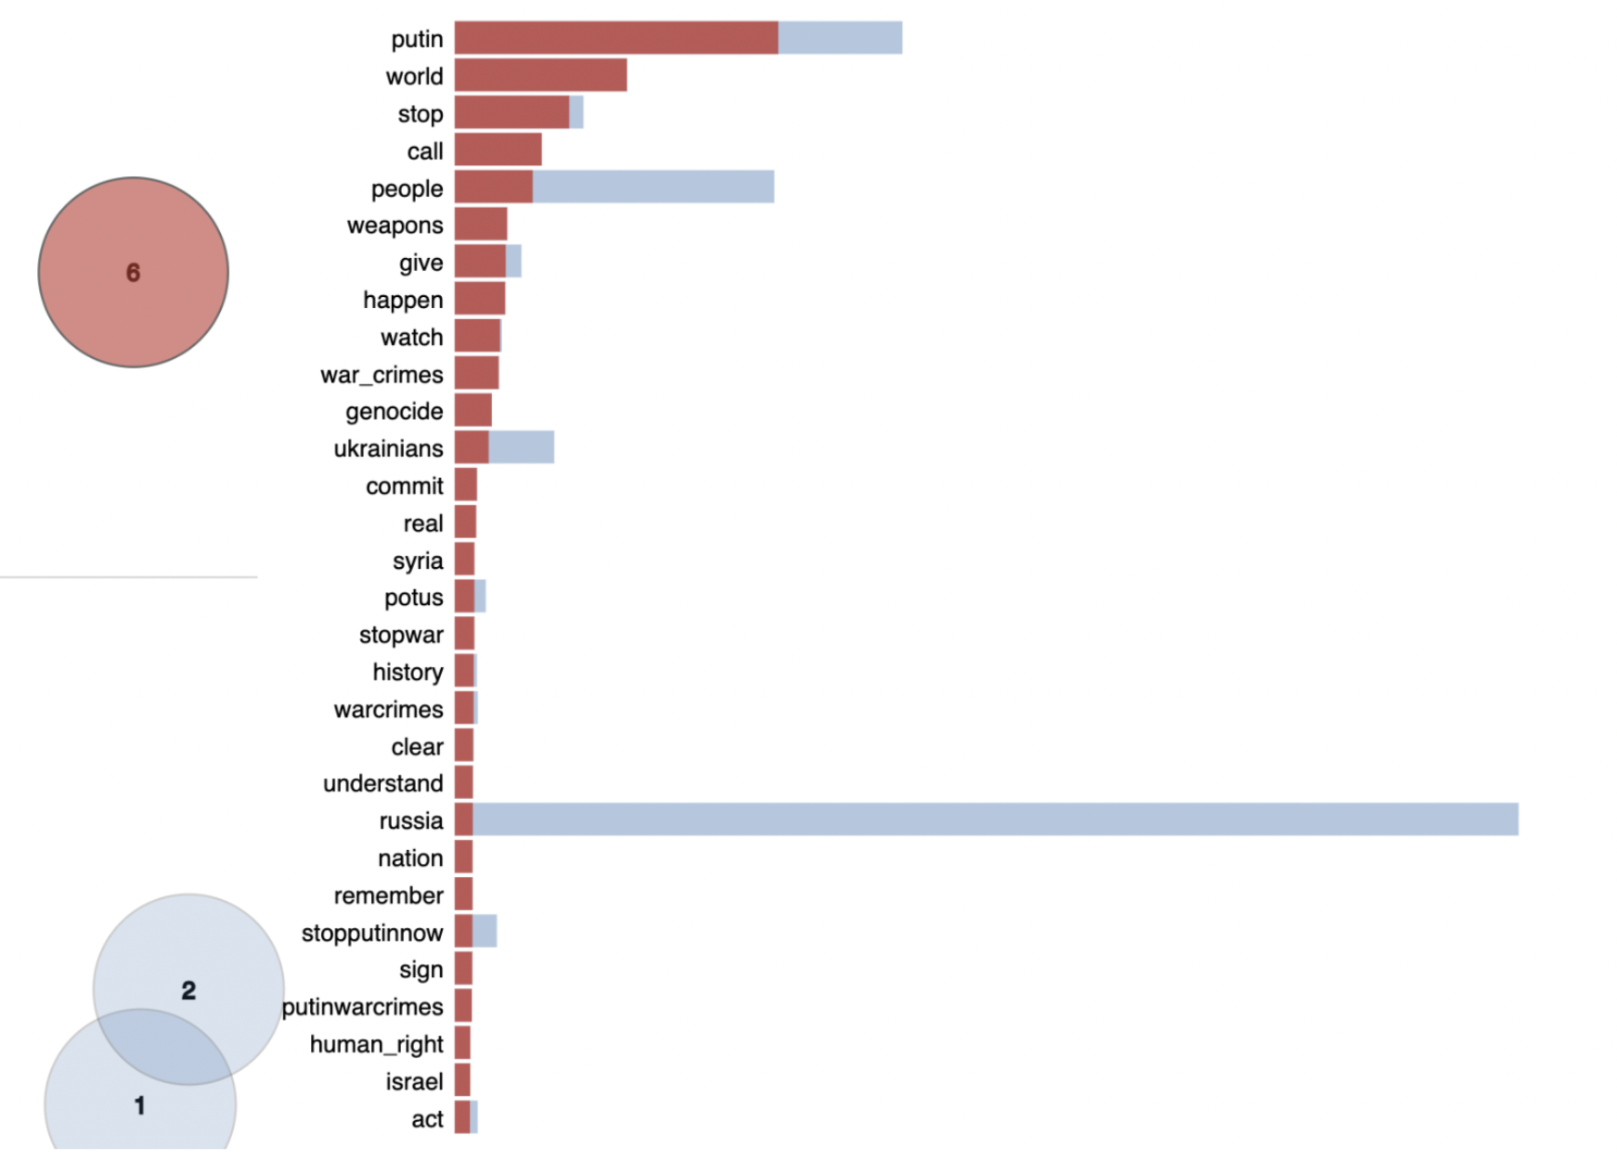

*Figure 3: The sixth topic cluster for our LDA model output. Although we don’t know the exact topic title for this cluster, we can check relevant words in this topic cluster.*

# **Challenges:**

The biggest challenge we faced when building the sentiment prediction model is to find the suitable dataset for training. We want our model to be able to predict several sentiments for one Tweet, after some exploration, we decide to use the Global Vectors for Word Representation dataset from Stanford University.

The next major problem we faced is to choose a decision threshold for our Bi-direction LSTM model. After some experimentation, we decide to use 0.37 as the threshold value because both the f1-micro score and the accuracy decrease after this value.

The final big problem we encountered is when training the LDA model, the size of the training dataset is too large. It will nearly cost us more than 10 hours to train the full model. The solution we figured out is that for each period (we divide the whole period from February 24, 2022 to May 1, 2022 to equally 11 parts), we randomly select 10,000 Tweets and combine all of them into a training set with 110,000 observations.

# **Reflection:**

Our model has successfully captured and modeled the sentiments evolution of Tweets from February 24, 2022 to May 1, 2022. Moreover, we have clustered all the Tweets into 12 underlying clusters. In the beginning, we only have a research question we want to explore, which is figuring out the general public’s opinion towards the Russia-Ukraine war. Since this question is too broad, we narrow it down to investigate English speakers’ opinions towards the conflict. Initially, we want to build an LSTM model combined with a dense layer to output sentiments’ probability. After some testing, we improve model accuracy by replacing the LSTM architecture with a bi-directional LSTM model. After finishing building the sentiment prediction model, we want to figure out the latent topics among all the tweets, so that we build an LDA model to cluster all the tweets into 12 topic clusters.

Some aspects we can improve on include when building the model, our sentiment prediction model doesn’t have high accuracy on the testing set, we should figure out a more robust architecture to increase test accuracy. When predicting on the Tweets dataset, we don’t have a label for the prediction. Thus, we must manually check the underlying sentiments for each Tweet. It will be more efficient if we can acquire a dataset with labels to predict. When building the LDA model, we realize that we need to acquire more reliable training data because when we are building the bi-directional LSTM model, we have used nearly 5,000,000 training data, but when we are building the LDA model, we just used around 110,000 training data.

# **Reference:**

[1] Mohammad, Saif, et al. "Semeval-2018 task 1: Affect in tweets." Proceedings of the 12th international workshop on semantic evaluation. 2018.

[2] BWANDOWANDO. "Ukraine Conflict Twitter Dataset." Kaggle. 2022.

[3] Pennington, Jeffrey, Richard Socher, and Christopher D. Manning. "Glove: Global vectors for word representation." Proceedings of the 2014 conference on empirical methods in natural language processing (EMNLP). 2014.

[4] Blei, David M., Andrew Y. Ng, and Michael I. Jordan. "Latent dirichlet allocation." Journal of machine Learning research 3.Jan (2003): 993-1022.

[5] Newman, David, et al. "Automatic evaluation of topic coherence." Human language technologies: The 2010 annual conference of the North American chapter of the association for computational linguistics. 2010.